Wilson Catcher’s Gear kit
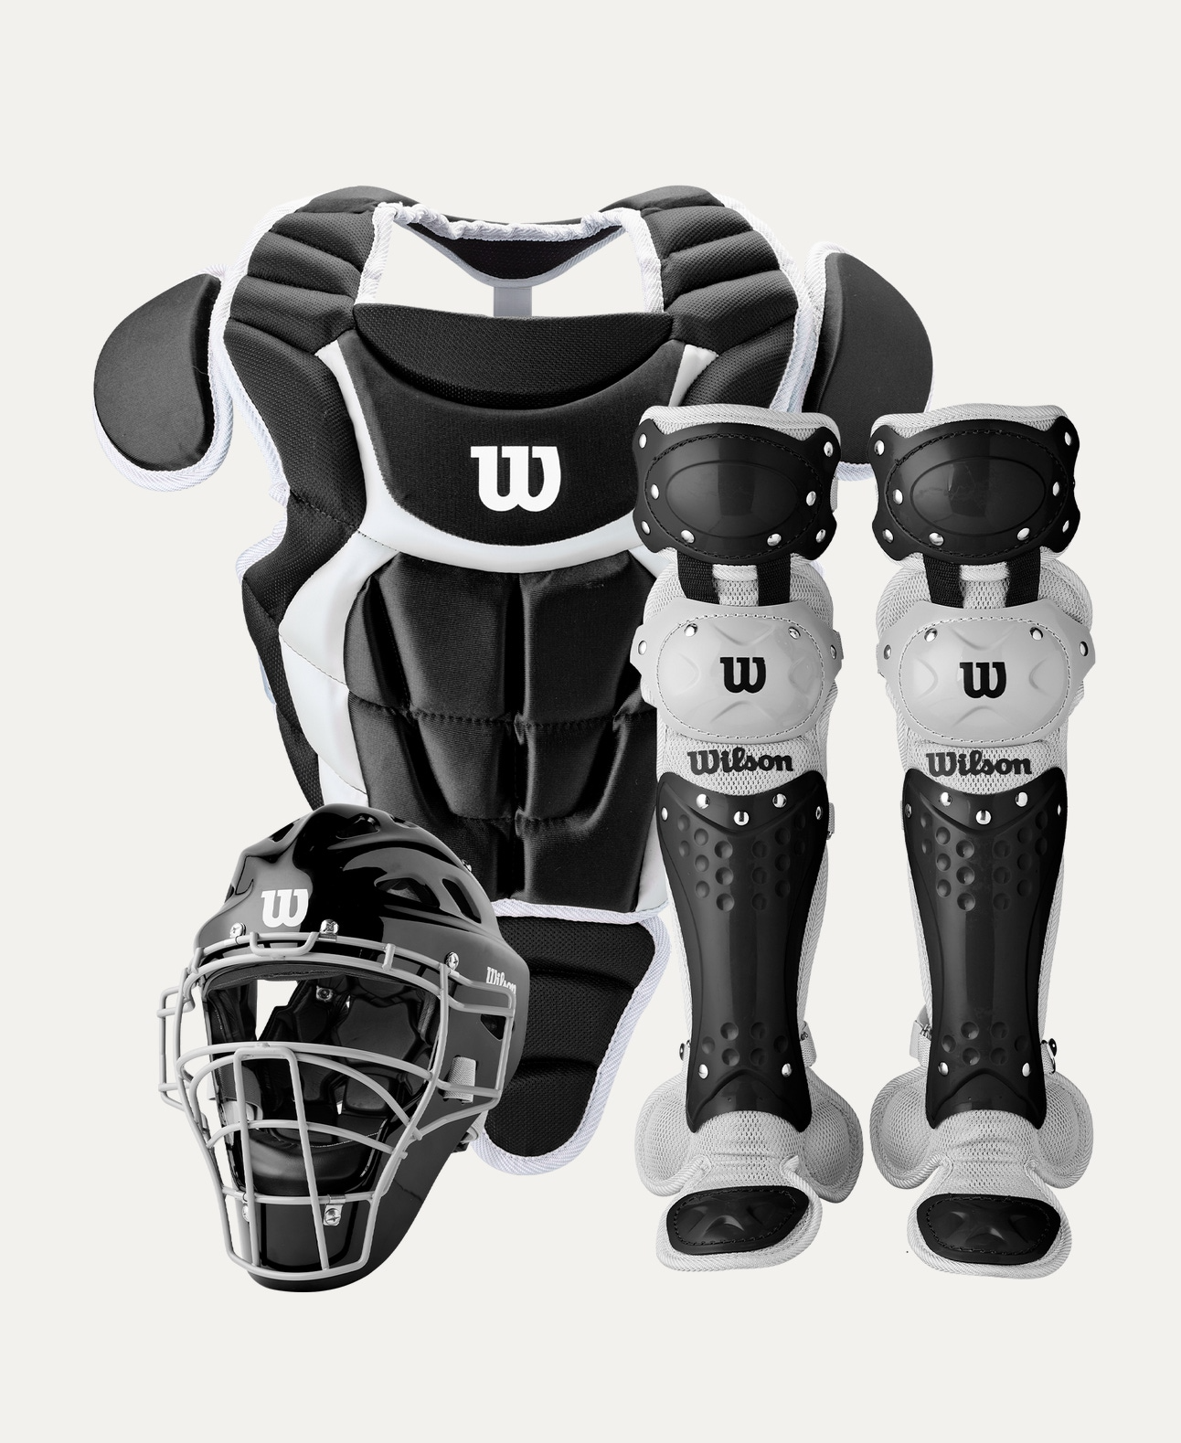
Price: Approximately RS 44,000
Introduction
The Wilson Catcher’s Gear Kit is designed to provide complete protection, comfort, and confidence for catchers during baseball and softball games. Built to meet professional safety standards, this kit ensures reliable performance behind the plate.

Product Overview
This Wilson Catcher’s Gear Kit includes essential protective equipment to safeguard catchers from high-speed pitches and impacts. Its ergonomic design allows free movement while maintaining maximum protection.

About the Brand
Wilson is a globally recognized sports brand known for producing professional-grade baseball equipment. Wilson catcher’s gear is trusted by players at all levels for its durability, safety, and performance.

Key Features
- Complete catcher protection set
- Shock-absorbing padding
- Adjustable straps for secure fit
- Lightweight design for mobility
- Suitable for training and match play

Design & Build Quality
The gear features a well-balanced design with reinforced protective zones. Its low-profile construction allows quick movements while maintaining comfort during extended gameplay.

Storage & Capacity
The kit can be easily stored in a standard catcher’s gear bag, keeping all protective items organized and ready for use.

Material & Durability
Made from high-quality plastic shells, steel components, and padded foam lining, the Wilson Catcher’s Gear Kit is built to withstand repeated impacts and long-term use.

Ideal For
- Baseball and softball catchers
- Youth, amateur, and professional players
- Training sessions and competitive matches
- School and academy teams

Care Instructions
- Wipe clean after each use
- Air dry padding thoroughly
- Check straps and buckles regularly
- Store in a dry, ventilated place

Product Specifications
- Brand: Wilson
- Product Type: Catcher’s Gear Kit
- Includes: Helmet, Chest Protector, Leg Guards
- Fit Type: Adjustable
- Usage: Training & Match Play

Product Summary
The Wilson Catcher’s Gear Kit offers complete protection, comfort, and durability for catchers at all levels. With trusted Wilson quality and professional design, it is an essential kit for safe and confident performance behind the plate.

Thank you

